Complex Simplicity
In this essay I am going to explore the concept of complex simplicity as expressed through my capstone project. Complex simplicity, the use for complex planning for simple things and using simple things for complex problems, are a core aspect of knots and knives. I will delve into the concept of complex simplicity by exploring the underlying themes of utility, versatility, and durability. These themes are a core aspect of my senior showcase which is comprised of a knot display, and a series of handmade knives.
The themes of utility, versatility, and durability are more easily seen in my knife’s series; however, they are present in my knots displays as well. For my knife display, I chose to focus on making knives for use in the outdoors. This meant placing an emphasis on having good quality steel and a well sharpened edge. An outdoor knife must be designed to be very robust (durability), must be able to perform multiple tasks (versatility), and must not be just for show (utility). For my knot display I chose to focus more on the utility and versatility aspects by choosing knots that are useful in day-to-day life and which are especially helpful in an outdoor scenario. Overall, both my knives and my knot displays embody the themes of utility, versatility, and durability and contribute strongly to the concept of complexed simplicity or in another words: simple things to fill complex needs.
There are several possible types of core considerations in any work of art. For my knife series, I focused a lot on shape, both of the knife blade and of the handle. With my later knives in particular, I focused a lot on curve. The shape of the knife will always be important as a poorly shaped blade or a clunky handle can take what would otherwise have been an excellent knife and make it unwieldy and next to useless. The idea of curve is especially important in a knife and utilizing both concave and convex curves gives the knife a good feel on the hand while also increasing its cutting potential. Most of my knives we’re designed to only have a single curve to allow for ease of sharpening, however I have included a couple of knives which were designed to have either multiple curves or a curve was added as part of the process of making and sharpening the knife. A specific example of this is my outdoor knife with a Koa wood handle (fig.1). The knife’s handle is shaped to fit well in the hand. The handle is also asymmetrical, which allows you to tell which direction the blade is facing by touch. That is an important feature, especially for knives that are likely to be used in suboptimal conditions, which are common while camping. The blade tapers to a point while maintaining strength, which leads to an aesthetically pleasing, and highly functional knife. Although difficult to see, the knife has a slightly concaved blade, which increases its ability to slice through materiel.
For my knot displays, I focused more specifically on space, with a particular emphasis on trying to manage the negative space around the knots so as to maintain a good balance of positive and negative space. I also chose to use color, and through the repetition of color to help convey both direction and continuity. I am especially pleased with the Man of War Sheepshank knot display (fig.2). It has a good balance between positive and negative space, and it deconstructs the knot well. The colors work well to show direction. The darker paracord, while making photographing difficult, also draws the viewer in so that they focus more on the knot, which helps facilitate understanding.
Another question people often have about art relates to how the piece was made. The techniques I used to construct my knives break down into two main categories, that of blacksmithing and that of more modern metalworking techniques. When I made my early knives in the series, I used modern metalworking techniques. I started with a metal blank and cut it down to the knife shape I had designed, typically having previously tested the shape with a wooden blank cut through the same shape. Once I had successfully cut down the metal blank to the desired knife shape, using either an angle grinder with a cutting wheel or a hacksaw, I then transitioned to the belt sander and carefully sanded the knife down to its final shape and then added the primary bevel. The primary bevel is where the knife blade transitions from its full thickness down to the edge, consisting of an angle shallower than is ideal for a knife blade cutting edge. I heat treated the blade in a ceramics kiln at 1900° Fahrenheit for at least a half hour followed immediately by quenching in oil to maintain the hardness after heat treating. I tempered the blade using typically my kitchen stove and two rounds of two hours each of heating at lower temperatures. This was followed by sharpening and grinding down the final secondary bevel which would allow for a sharp knife with a more robust angle of the blade.
For the knives that I made using blacksmithing, I would first heat and then hammer the metal into the general shape of the desired knife. This would require many heating sessions over several days depending on the size of the knife and how much the metal had to shift before I could start the grinding process. Once the knife was as close to the final shape as I could reasonably accomplish using blacksmithing techniques, I would then do a final heating and quench the blade in oil, as opposed to water, to heat treat the knife and produce a harder steel. After this process, I used the belt sander to grind down the knife to the final desired dimensions, and then I polish and sharpen the knife. For most of my blacksmithing blades, I opted not to add any additional material to the handles. However, for one larger knife, I used a hole pin method to attach a handguard and then I used epoxy to help attach the leather handle that I stitched tight to the metal handle.
While the knot displays required less technical skill and technique to make compared to the knives, they still required a deep understanding and breadth of knowledge of knot craft. I had to both be able to tie many different knots and understand how to deconstruct the steps of tying them. The knot displays went through several iterations in order to give the knot boards a nice clean finished look. I achieved that look using drilled holes and hot glue carefully applied to the back to hold the paracord. I also carefully heated the rope in strategic locations to cause it to stiffen slightly to help it retain its shape. Additionally, I adding nails through the back of the mounting board that were then embedded in and super glued to the rope. This allowed for a very secure mounting, with the embedded nails serving as a repairable mounting for gluing in the field, allowing these art pieces to be used effectively in an outdoor setting. Size and available materials where two key considerations in choosing the method of displaying the knots. I chose to use plywood as the backing because there was plenty of scrap material available, as well as my prior experience with working with wood. I have found throughout my years of experience with knots that paracord is a very versatile and commonly available rope, with the added benefit of being produced in multiple colors, which allows for differentiation between different ropes making up a knot. I also chose to add a very large diameter rope to the front of my display in an effort to help draw in the audience to come and see the knots display.
Another consideration when looking at art is exploring the artist’s inspirations that influenced the work. The inspiration for my knives tends to fall into one of two categories, outdoor very rugged knives, such as you might see for the military and survival knives, and the other is historical or fantasy knives. In particular the Japanese Katana has been an influence on my work as is evidenced in my blacksmithing knives. I also drew inspiration from medieval swords and swords from fantasy depictions such as the Lord of the Rings. Unfortunately, due to the coronavirus closure, those projects that were drawn more heavily from the medieval/fantasy knives had to be put on hold, possibly indefinitely. Another significant influence on my knife designs is my years spent in Scouting. As a scout I learn to be prepared and a good knife is an essential tool for being prepared. In order to use a knife in the Scouting program, I had to earn the Whittling Chip (Cub Scouts) and the Totin’ Chip (Boy Scouts). Both achievements required me to both learn and practice safe knife handling, which is why I put an emphasis on making sheathes for my knives so that I don’t have to deal with safety issues related to an exposed blade.
In regards to knots, most of my influence comes from Scouting. In particular, one of my scout leaders, who was especially good at knots, taught me most of the knots I use today. The main types of knots I know and use include knots for creating loops, knots for creating connections between two ropes and knots for attaching to an object. Additionally, I have learned to tie knots that I would classify as show knots, as they are not commonly used due to the complexity or unnecessary showmanship of the knot, which means they are not known widely. However, I still believe that knowing how to tie a rare knot or two is still a useful thing. It is always good to be able to teach someone else a knot that you know, especially if you are exchanging knowledge by learning from them and asking them to teach you knots that you are not familiar with.
Throughout my work on my senior capstone, I spent a lot of time designing and creating works that epitomized the idea of complex simplicity. For my knife series, I labored to design and construct a series of functional knives that would be simple enough to be made with the resources available here at Pacific. I designed and carefully crafted them for use on a wide array of outdoor applications and to last for years to come. With my knot displays, I strove to find a series of knots that truly covered a wide variety of needs and complexity. I worked to ensure that both my knots and my knives would be very robust and long lasting (durability). Each had to be practical and usable for both myself and others (utility). They also were designed to be to work in a variety of applications, both seen and unforeseen (versatility). Ultimately, I believe I succeeded in making my knot displays and my knife series conform to the idea of complex simplicity. Now that just leaves one question: “What else can be made better by following the principle of complex simplicity?”.

Figure 1
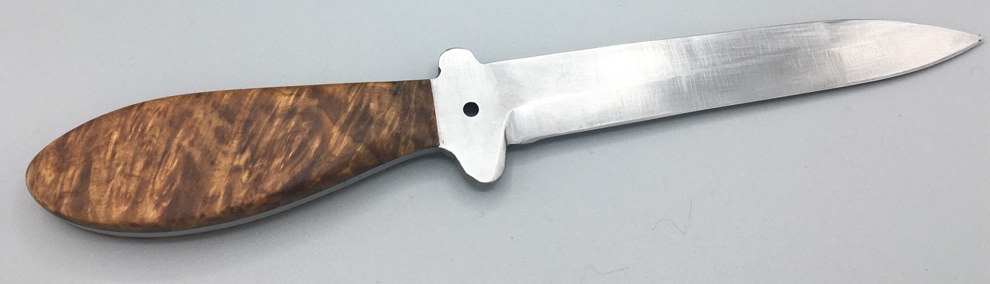
Outdoor Knife with a Koa Handle

Figure 2
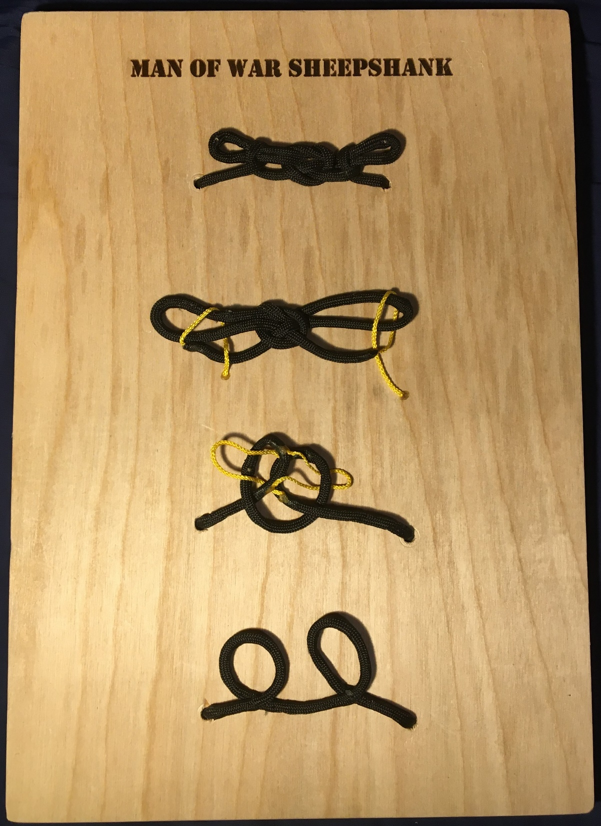
Man of War Sheepshank, knot display

